


Trainify


Contents
1. Team Roles 3
2. Project Planning 4
2.1. Project Overview 4
2.2. Project Objectives 4
2.3. Project Scope 4
2.4. Tech Stack 4
2.5. Functional Requirements 4
2.6. Non-Functional Requirements 5
3. Stakeholder Analysis 6
4. UI/UX Design 7
4.1. Design Philosophy 7
4.2. Visual Identity 7
4.3. Key Design Elements 7
5. Conclusion 9

1. Team Roles
- Amr Khaled :
- Youseif Elshreif :
- Ahmed Emad :
- Kevin Romany :
- Steven Haroon :
- Mohamed Tarek :

2. Project Planning

2.1. Project Overview
Trainify is a modern, full-featured fitness management platform designed to empower users to track their fitness journey, manage meal plans, access workout programs, and utilize a suite of advanced fitness calculators. The platform is built to serve three distinct user roles (Visitors, Users, Admins) and emphasizes a high-quality user experience (UX) through smooth animations, responsive design, and intuitive navigation.

2.2. Project Objectives
- User Empowerment: Provide registered users with easy-to-use tools (a personal dashboard, tracking) to manage their health goals.
- Specialized Content Delivery: Offer curated meal plans and training programs assignable by subscription tier (Gold/Platinum/Diamond).
- Centralized Management: Equip administrators with a powerful dashboard for full CRUD (Create, Read, Update, Delete) operations on all platform content and user accounts.
- Lead Generation & Engagement: Attract new users (Visitors) by offering valuable, free tools (8 advanced fitness calculators) and a compelling landing page.

2.3. Project Scope
The project's scope is defined by three primary user-facing interfaces:
- Public Interface (Visitor): Includes the multi-section Landing Page, the 8-tool Calculator page, and the authentication pages (Login/Register).
- User Interface (User): A protected area (/user-dashboard) featuring a tab-based system for viewing personal information, assigned workouts, meal plans, and subscription status.
- Admin Interface (Admin): A protected area (/dashboard) with a sidebar, overview statistics, and data-table-driven pages for managing meal plans, training programs, and users.

2.4. Tech Stack
- Core: React 19.1.1, TypeScript 5.9.3
- Build Tool & Routing: Vite 7.1.7, React Router 7.9.4
- Styling: Tailwind CSS 3.4.12, PostCSS, Custom CSS Animations
- Form Management: Formik 2.4.6, Yup 1.7.1
- Authentication: React Context API with Local Storage persistence.

2.5. Functional Requirements

2.5.1. Public & Authentication
- FR-1.1 (Visitor): The system shall display a landing page with Hero, About, Services, and Contact sections.
- FR-1.2 (Visitor): The system shall provide access to 8 distinct fitness calculators (BMI, BMR, TDEE, etc.).
- FR-1.3 (Visitor): The system shall allow a visitor to register a new account and an existing user to log in.
- FR-1.4 (System): The system shall validate all inputs on the Register and Login forms.
- FR-1.5 (System): The system shall implement protected routes, redirecting unauthenticated users to the login page.

2.5.2. User (Authenticated)
- FR-2.1 (User): The system shall display a personal dashboard (/user-dashboard) with four tabs (Info, Workouts, Meals, Plan).
- FR-2.2 (User): The user shall be able to view detailed workout cards and meal plan modals.
- FR-2.3 (User): The system shall provide a "Logout" function.

2.5.3. Admin (Authenticated)
- FR-3.1 (Admin): The system shall display an admin dashboard (/dashboard) with overview metrics.
- FR-3.2 (Admin): The admin shall have full CRUD capabilities for Meal Plans and Training Programs.
- FR-3.3 (Admin): The admin shall have User Management capabilities (View, manage roles).
- FR-3.4 (Admin): All management pages shall feature data tables with sorting, pagination, and search.
- FR-3.5 (System): The system shall enforce role-based access, preventing Users from accessing admin routes.

2.6. Non-Functional Requirements
- NFR-1 (Performance): The application must load quickly, leveraging Vite. All animations must be smooth (60fps).
- NFR-2 (Usability): The application must be fully responsive (mobile, tablet, desktop).
- NFR-3 (Usability): Navigation must be intuitive for all user roles.
- NFR-4 (Maintainability): The codebase must be written in TypeScript for strict type safety and adhere to ESLint rules.
- NFR-5 (Security): Authentication state must be securely managed. All user input must be validated (via Yup) before submission.
- NFR-6 (Visuals): The application must provide clear visual feedback for loading states and error messages.

3. Stakeholder Analysis
This analysis identifies the key parties involved in the project, their interests, and their primary requirements.
Stakeholder | Description | Key Interests | Primary Requirements
Visitors | Public users who have not logged in. | Exploring services, gaining quick value, assessing trust. | • Fast-loading, attractive landing page.  • Easy access to the 8 fitness calculators.  • A clear and simple registration process.
Regular Users | Authenticated users with personal accounts. | Tracking personal progress, adhering to plans, achieving fitness goals. | • A secure, personalized dashboard.  • Clear presentation of assigned workouts and meals.  • Ability to manage their profile and subscription.
Admins | System administrators responsible for content and user management. | Content quality, platform health, user activity monitoring, efficiency. | • A comprehensive dashboard with full CRUD.  • Powerful data tables (search, filter, sort).  • The ability to manage user roles and status.
The Company | The owning/sponsoring entity of the Trainify platform. | User growth, brand reputation, platform stability, and long-term scalability. | • A secure and scalable architecture.  • A professional design that reflects the brand.  • A robust, bug-free system.

4. UI/UX Design

4.1. Design Philosophy
The design philosophy for Trainify is centered on creating a modern, smooth, and intuitive user experience. The goal is to reduce user friction and make fitness management feel effortless. This is achieved through a clean interface, purposeful animations, and a highly responsive layout that prioritizes clarity and ease of use.

4.2. Visual Identity
- Color Palette:
  - Primary Gradient: A vibrant gradient from #FF6B35 (Energy Orange) to #2BC48A (Vitality Green), used for key CTAs and branding.
  - Text & Neutrals: A full grayscale palette for text and backgrounds to ensure readability.
  - Semantic Colors: Standard Green (Success), Red (Error), and Blue (Info) for user feedback.
- Typography:
  - Font Family: System-native sans-serif stack for optimal performance and legibility.
  - Hierarchy: Strong hierarchy achieved with bold weights for headings and regular weight for body text.

4.3. Key Design Elements
- Glassmorphism: Utilized on cards and modals to create a sense of depth and a modern, translucent aesthetic.
- Smooth Animations: Applied to component loading, hover interactions, and page transitions.
- Responsive Design: A mobile-first approach using Tailwind CSS ensures a seamless experience on all devices.
- Custom Scrollbar: The browser scrollbar is custom-styled to match the brand's color palette.
- Icons: A consistent icon set from React Icons is used to reinforce actions and navigation visually.

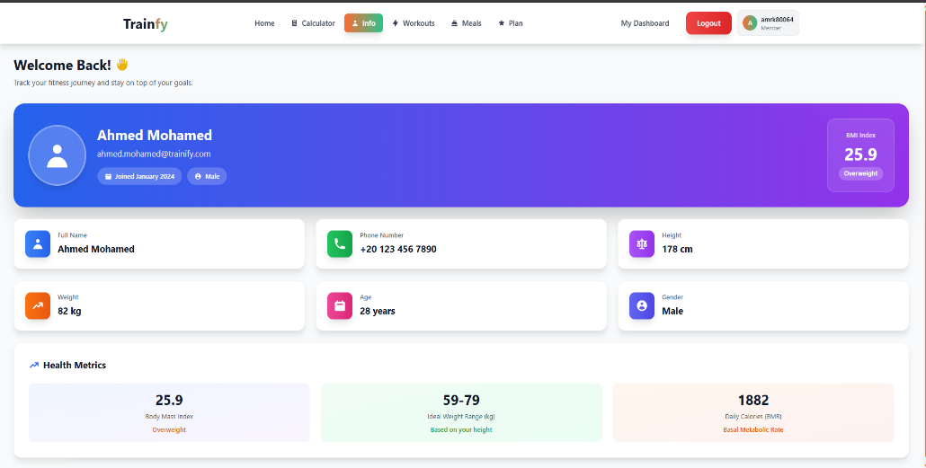
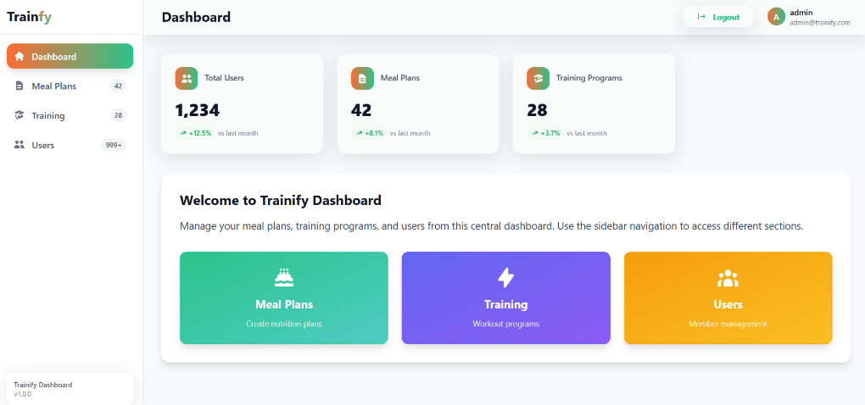
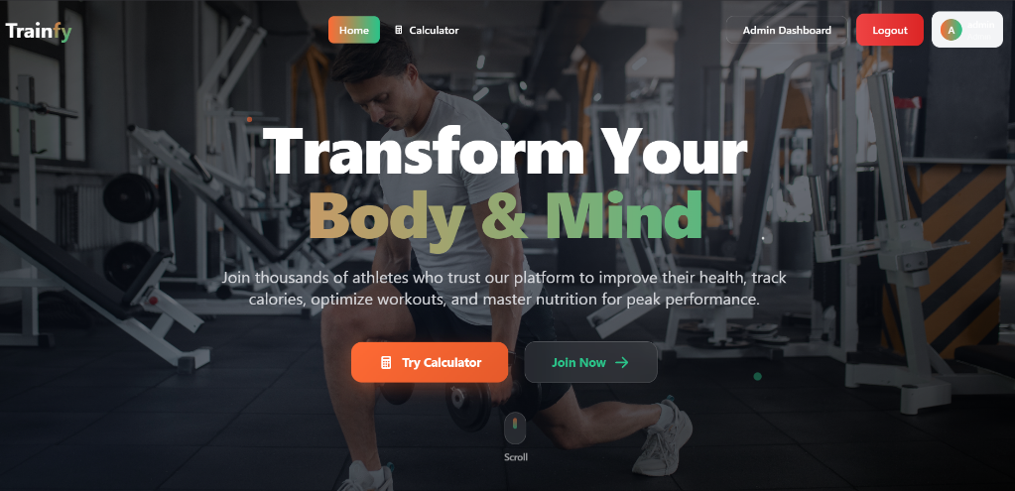
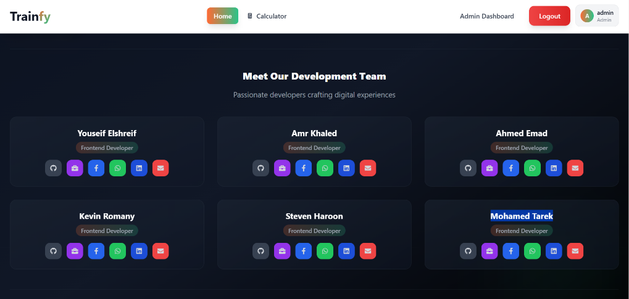

5. Conclusion
The Trainify project successfully fulfills its objective of delivering a comprehensive and modern fitness management platform. Through careful planning, a robust tech stack based on React and TypeScript, and a user-centric design philosophy, the application provides distinct, high-value experiences for Visitors, Users, and Administrators.
All functional and non-functional requirements have been addressed, resulting in a performant, scalable, and secure application ready for deployment. The platform effectively balances rich functionality with an intuitive, engaging, and visually appealing user interface.

